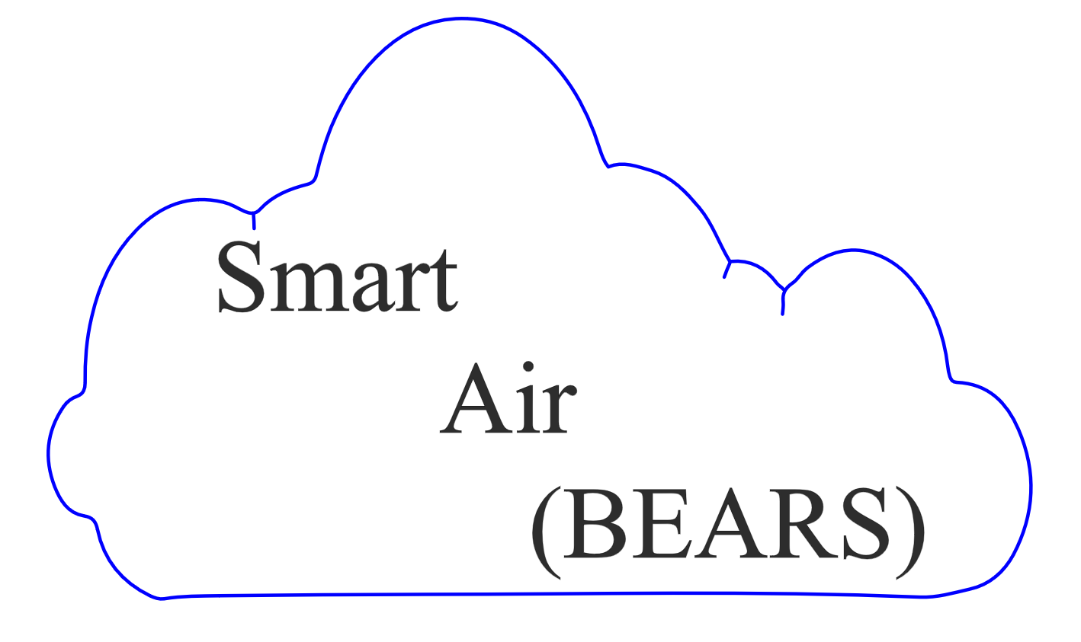

*empowered personal pollution monitoring*

*for all*

**Garima Raheja**

**John Stuart**

**Matt Choi**

**Brian Tam**

2.5 Final Report [20 pts]

The project report parameters are as follows:

• Page limits: 12-20 pages single column, or 6-12 pages double column with ﬁgures and references

• Submitted on bCourses under “Final Project Report” Assignment

**Abstract**

(II) [Abstract] Summarize the project in 200 words or less. Make sure to include: (i) statement of project; (ii)brief indication of how it is unique; and(iii)a“back-of-the-envelope” stylecalculationthatquantiﬁes the impact if the project were fully-scaled.

The air we breath in is such a vital part of our lives that it deserves to be monitored and recorded in a cost effective, user friendly manner. Currently, personal air quality monitors price in the hundreds. The expense and impracticality of these systems limits the awareness we have on the air we live in.

The purpose of this project is to prototype a cyber-physical system that could be budgeted and easily implemented into societal use. Our development and validation process, requires us to hardware a wide range of sensors into our arduino board, monitoring PM, VOCs, CO2, as well as temperature and relative humidity and provides health recommendations to help users achieve healthier lifestyles.

**Introduction**

Air, shelter, water and food. Human beings require all four of these basic needs for survival. While society sees the importance of engineering our infrastructure to accommodate for our basic need of shelter, it is without a doubt that civil engineers play a role in all four of these requirements to ensure the survival of our species.  
 Effects of air quality on health, happiness, and productivity

A.s.h.r.a.e criteria

A way to give advice to the user on how to improve their air quality.

Motivation and Background

(a) [Motivation & Background] This section provides answers to the following questions. Why is this topic interesting and important to study? What are the challenges associated with managing this particular infrastructure system? Teams may optionally indicate how their previous experiences uniquely position themselves to study this topic. Teams may also indicate how this topic synergistically combines with their own research, other classes, etc.

As energy efficiency and construction practices improve, ventilation

Relevant Literature

b) [Relevant Literature] Summarize the key references that provide relevant background for your project topic. These references should be included in an enumerated list at the end of the document. These references can include published articles, textbooks, etc.

Focus of this Study

(c) [Focus of this Study] Provide a precise statement of this project’s focus. Make it precise and simple.

Make smart air quality both affordable and user friendly

**Technical Description**

(IV) [Technical Description] The bulk of the report is the technical description. You are free to structure this section in whatever manner best conveys your project design and results. This section must include the following elements:

• A schematic of your CPS architecture (see ﬁgure in Lab 5, Part 2) • A “bill of materials” describing all your hardware components • A detailed description of your hardware. Provide photos. Describe design iterations, challenges, and solutions. • An outline, enumerated list, or diagram of the software code/functions. • A mathematical description of the data analysis. Use equations please. • A presentation and analysis of the data collected • An overview of the visualization tool. Provide screenshots.

The adage “a picture is worth a thousand words” holds true in technical writing. Use mathematics and equations. Mathematics provides a concrete and precise description, and avoids the subjectivity of word descriptions.

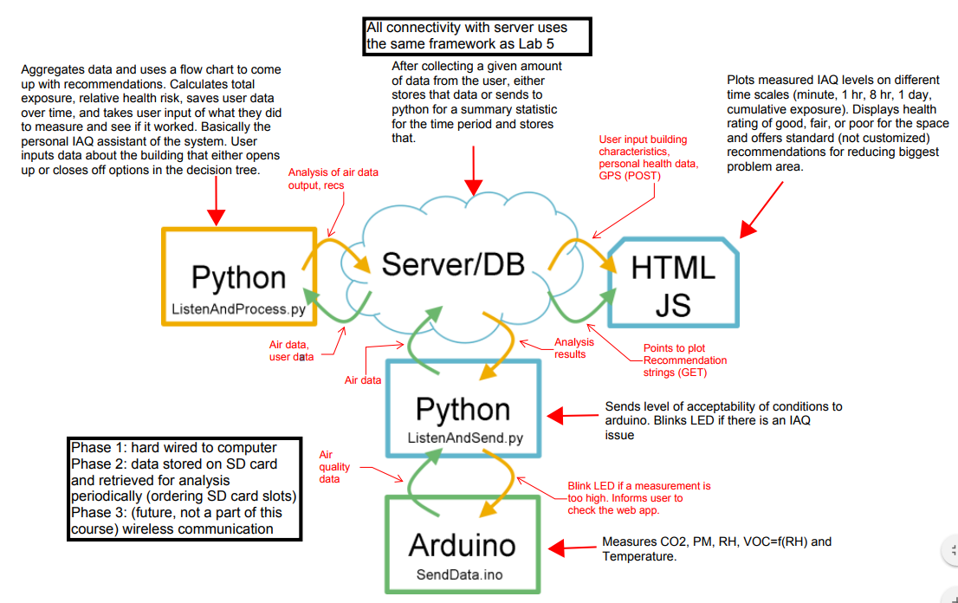

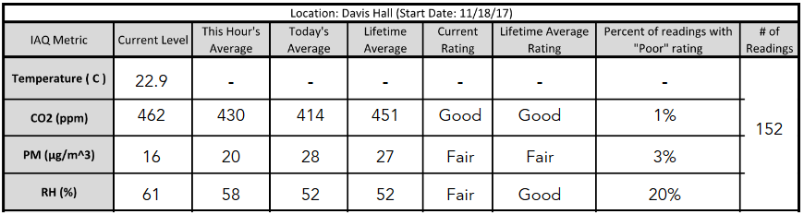

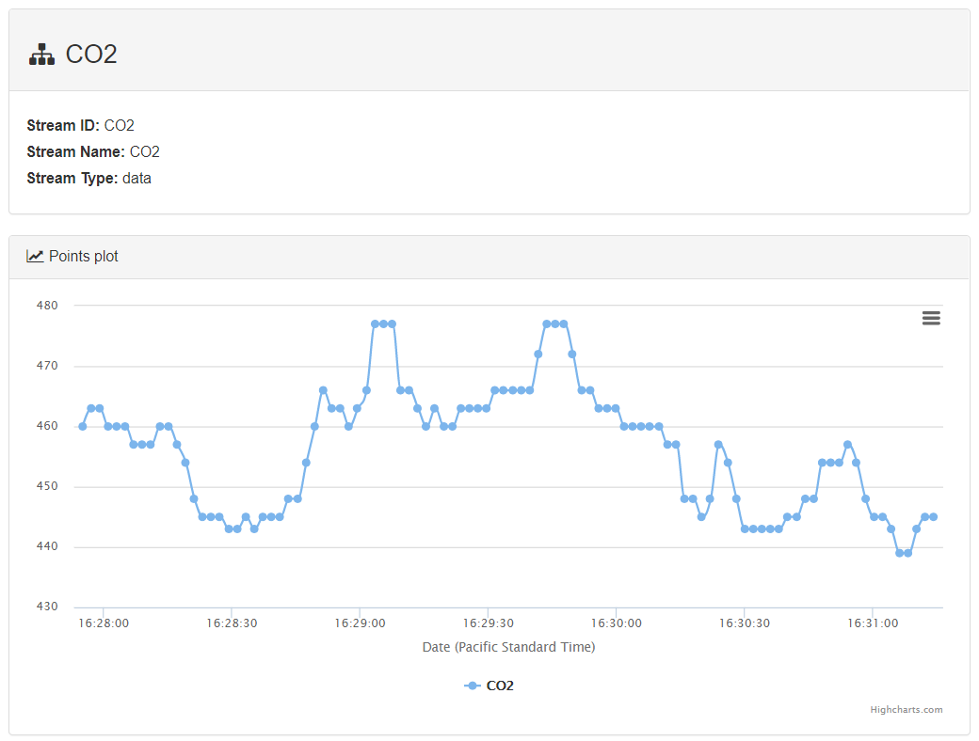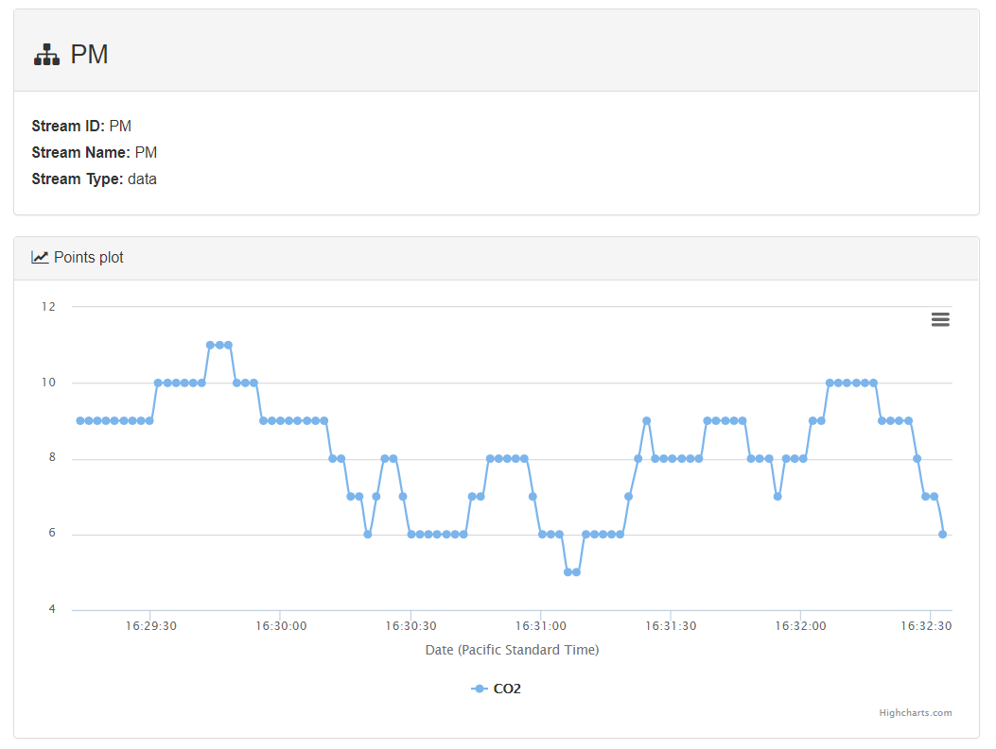

**Discussion**

(V) [Discussion] Provide a thoughtful discussion of your CPS project. What infrastructure system problem does it solve? How does it solve it? What innovations does it provide? Expand on your back-ofthe-envelope calculation. Detail this calculation, and discuss the opportunities and challenges of fully scaling your CPS project.

**Summary**

(VI) [Summary] Summarize the project’s aim and results. A reader should understand the main ideas by only reading the abstract and summary.